--------------------------------------------------------------------------

OOPM - MOCK PRACTICAL  
YASH SARANG. D6AD / 47.

--------------------------------------------------------------------------

AIM: Write a JAVA program to demonstrate the concept of arithmetic operators.

--------------------------------------------------------------------------

Program:

*import java.lang.*;*

*import java.util.*;*

*public class ArithmeticOperators {*

*public static void main(String[] args) {*

*int a = 12, b = 5; //declaring,initializing the variables.*

*System.out.println("a + b = " + (a + b)); // addition operator*

*System.out.println("a - b = " + (a - b)); // subtraction operator*

*System.out.println("a * b = " + (a * b)); // multiplication operator*

*System.out.println("a / b = " + (a / b)); // division operator*

*System.out.println("a % b = " + (a % b)); // modulo operator*

*}*

*}*

--------------------------------------------------------------------------

Writeup:

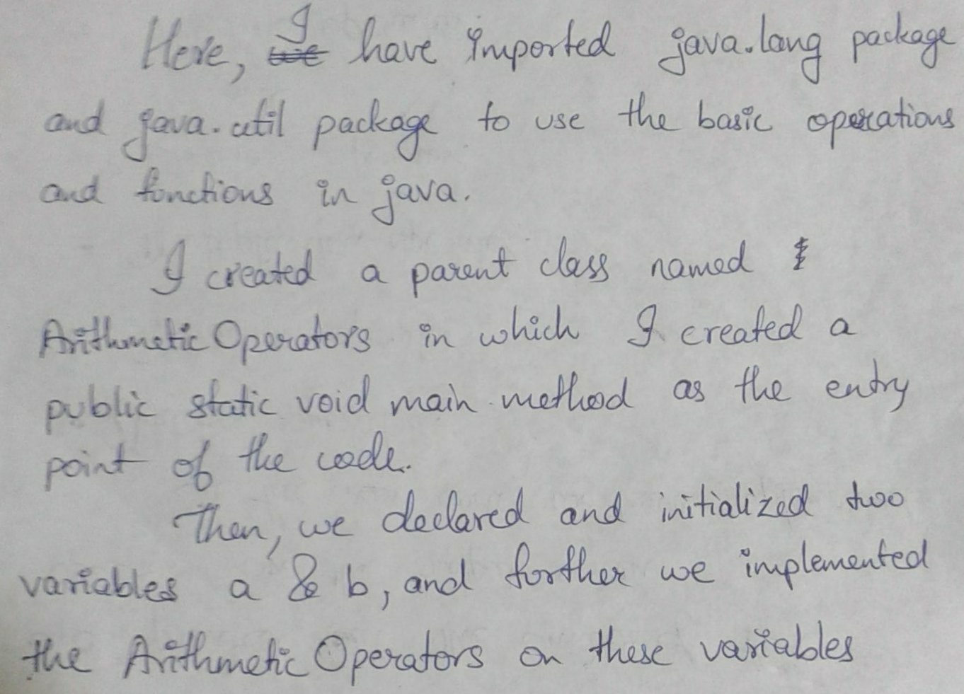

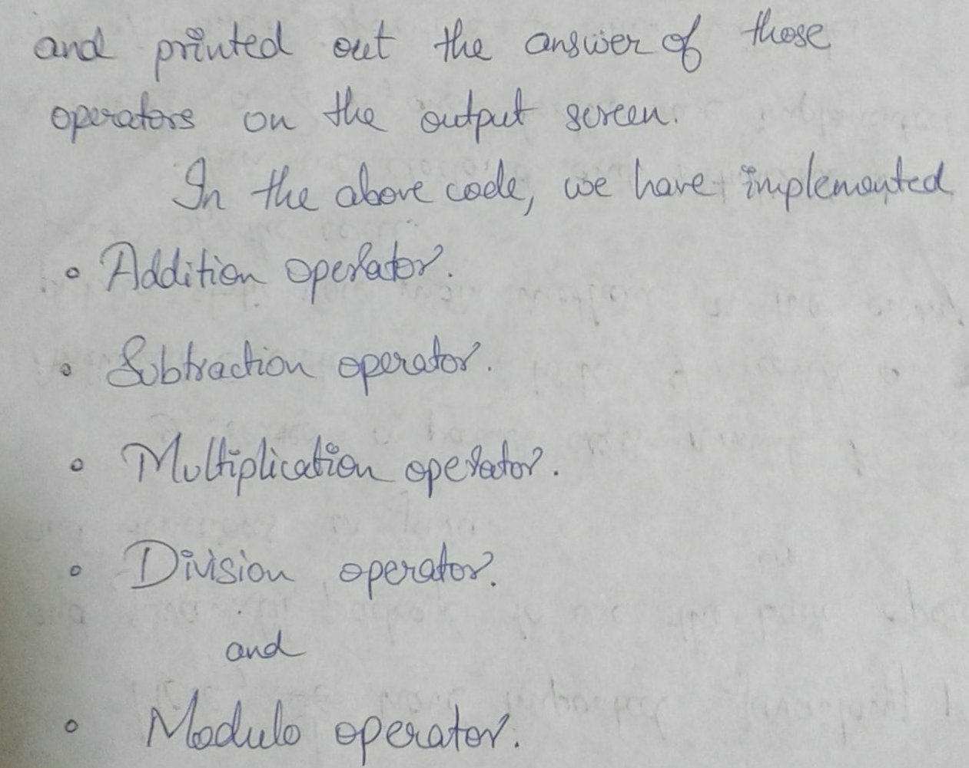

--------------------------------------------------------------------------

**OUTPUT:**



